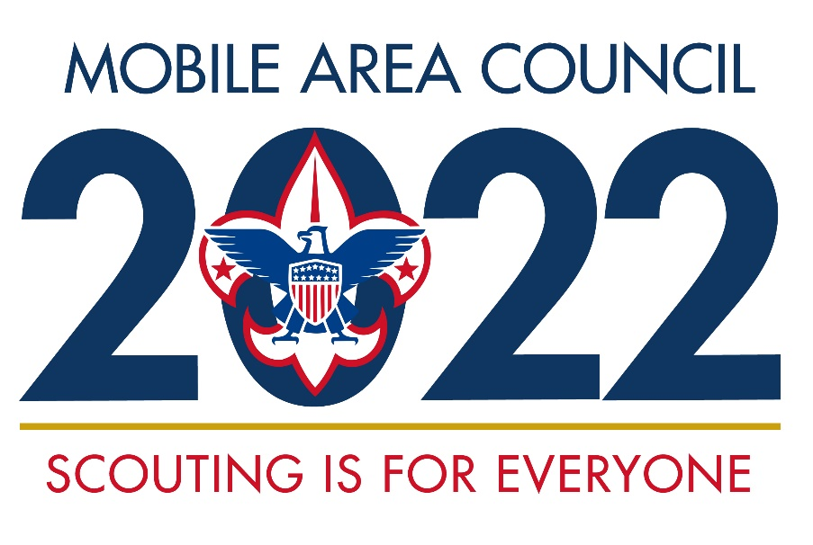
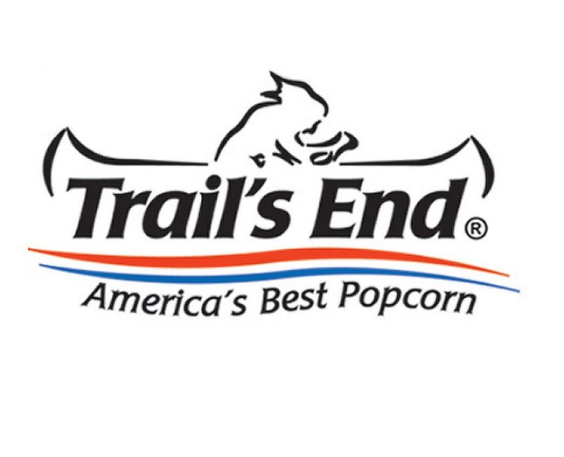

2022 Popcorn Leader Guide

Popcorn Kernel Job Description

By accepting the invitation to become your unit’s Popcorn Kernel, you are ensuring the sale is a success. Your primary responsibilities are to manage all aspects of the sale, clearly communicate sale information to your leaders, parents, and Scouts, and host a dynamic kick off. Training and documents that will help you prepare for a successful sale will be distributed at the Unit Training Meetings, your August Roundtable, and are available on the council website (www.bsamac.org).

- Promote the 35% commission plan and attend one of the July training meetings for the District Kernels and unit leaders.

- Assist in setting up a sales plan for your unit that includes the 3 methods of selling popcorn: Take Order, Show and Sell and Online.

- July / August - Attend the District Popcorn Kick-Off meeting at the District Roundtable August 4th for Baldwin & August 11 for Five Rivers.
- Organize and conduct a successful Unit Popcorn Kick Off
- Communicate purpose for the sale and timeline to your Scouts and parents.
- Assist in setting unit and per-scout goals based on your activities calendar.
- Distribute sales materials to all Scouts and families.
- Set up Show & Sell locations and dates.
- Assist in distributing popcorn for Show and Sells.

- September/ October - Follow-up
- Inspect, coach, and praise your Scouts.

- November / December – Ensure all online popcorn and online prize orders are complete in Trail’s End system.
- Distribute Take Order popcorn and collect money from parents.
- All payments due council (total sales - unit commission = payment due council) must be submitted by or before December 2.

Mobile Area Council Popcorn Prizes 2022

In addition to the prizes offered by Trail’s End, the Mobile Area Council is offering:
Weekly Drawings
To be eligible for weekly drawings, you may email, or hand deliver a printout of your Scout’s sales report from your mobile app or a copy of your paper order form. All submissions MUST be in the office before 12:00noon on the below dates of the drawing.
Email: Brandon.Anderson@scouting.org

Sell $100 by August 29th to be entered to win an EDGE Gaming keyboard
Sell $250 by September 6th to be entered to win a Blast Beat
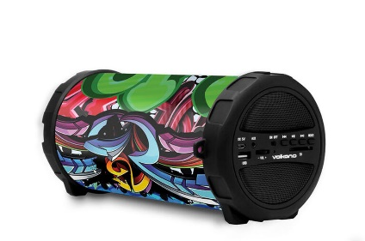

Sell $350 by September 12th to be entered to win an Aqua Beat

Sell $500 by September 19th to be entered to win an EDGE Gaming Keyboard and Art and Sound earplugs
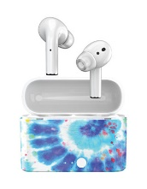

You DO NOT need to resubmit forms already turned in, unless the Scout has additional sales that qualify them for a higher level. Council will automatically move forms to qualifying levels after each drawing. Make sure you have parent and scout’s name and a reliable adult phone number on the submitted form.

Level Up Club
Scouts who sell $1,000 or more will receive a $50 amazon gift card.

District Top seller
Both Baldwin and Five River’s Top Seller Scout of at least $10,000 will receive a VIP Experience at the 2023 Reese’s Senior Bowl sponsored by Wind Creek Hospitality.

*Scout’s Sales include total sold from Take Order, Show & Sell, and Online Sales.

2022 Popcorn sale timeline
July 14 Popcorn Training, 6pm (Required for possible 35% commission)
USS Battleship.

July 21 Popcorn Training, 6pm (Required for possible 35% commission)
Virtual training via Zoom

AUG. 3 Deadline to submit Unit’s Show and Sell order online; Unit Commitment Forms due to Bernadette at Council Service Center

AUG. 10 Units pick up popcorn order* (date may change due to Trail’s end)

AUG. 15 Units may pick up extra popcorn from Council Service Center as needed, until product is depleted.

Oct. 31 Deadline for Unit’s Take Order submission online

Nov. 16 Units pick up popcorn order* ((date may change due to Trail’s end)

Nov.16-30 Deliver popcorn to customers & collect money. Turn collected money in to Council Service Center.

Dec. 2 Popcorn season is over! All payment due to Council by 5pm. Prizes are released from Trail’s End when balance owed to council is $0.

Dec. 5 Unit Commission drops to 25%

Dec. 12 Unit commission drops to 15%

*Unit will receive an invoice with orders and payments received.

Show & Sell and
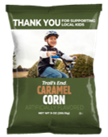
Take Order products

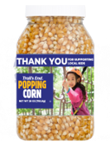
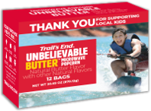

$25 unbelievable butter Microwave
$15 Caramel Corn
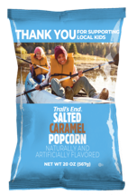
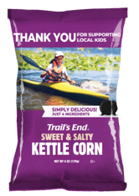
$15 popping Corn
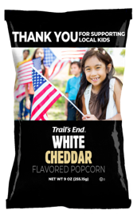

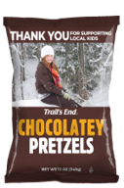
$25 Salted Caramel
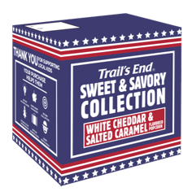
$25 White Cheddar
$25 Kettle Corn

American Heroes Donation
$45 White Cheddar and Kettle corn
$25 Chocolatey Pretzels
POPCORN Order Guide

Use this reference guide for ordering Show & Sell. The cost and amount of pieces per case are listed next to the product.
Remember: Units order Show & Sell inventory by the case; Take Order can be ordered by the individual pieces.

Product | Price/ Pieces per case | Amount to Order
Caramel Corn | $15/ $180  (12 per case)
Popping Corn | $15/ $135  (9 per case)
Unbelievable Butter | $25/$150  (6 per case)
Kettle Corn | $25/ $300  (12 per case)
White Cheddar | $25/ $200  (8 per case)
Salted Caramel | $25/ $300  (12 per case)
Chocolatey Pretzels | $25/ $300  (12 per case)
White Cheddar and Kettle Corn | $45/ $450  (1 per case)

Support
COUNCIL ​
Brandon Anderson: District Executive
Brandon.Anderson@scouting.org
(251)476-4600

Sonya Seabrook: Administrative Assistant
Sonya.Seabrook@scouting.org
251-476-4600

Mary Phillips: Registrar
Mary.Phillips@scouting.org
251-476-4600

Bernadette Toler: Popcorn Staff Advisor
bertoler@scouting.org
251-656-2399

​District Kernels
Kelly Dunbar: Baldwin District Kernel
kkellytorp@aol.com​
(251)680-9289​

Charles Harris: Five Rivers District Kernel
CharlesHarris2@ccbcu.com
251-295-1977

https://www.bsamac.org/support-scouting/popcorn ​

TRAIL’S END/ Online
JOIN TE FACEBOOK GROUP​
Text FACEBOOK to 62771 to join​

​JOIN TE WEBINARS​
Text WEBINAR to 62771 to register​
​
VISIT TE WEBSITE​
www.trails-end.com​
​
EMAIL TE:​
support@trails-end.com​
​
​NEED HELP? VISIT TE FAQs:​
support.trails-end.com​
​

