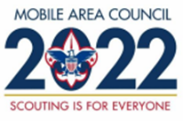
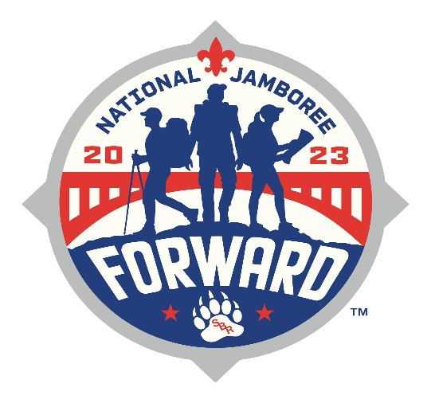
National Jamboree
July 19th-28th, 2023
Youth Participant Registration Form

Youth Name: ____________________________ Unit:________________
Age:______________ DOB:________________ Current Rank:___________
Phone:________________ Email:__________________________________
Address:_____________________________ City:___________ Zip:________
Unit Leaders Name:______________________ District:_________________
Unit Leaders Phone:_________ Unit Leaders email:____________________
Your leader will be contacted and approval of leader will be required to attend on the contingent.
Parent/Guardian Name:___________________________________________
Adult Phone:_______________________ Alt. Number:_________________
Parent/Guardian Email:__________________________________________
Read code of Conduct/Physical Requirements: Scout initials:______ Adult Initials:______
*Deposit of $250 due immediately. Balance due in Full by April 14th,2023.
Paid Date:___________ Check/Cash/Credit Card Receipt Number:_________
May 13th, 2022 $175 | November 15th, 2022 $175
June 15th, 2022 $175 | December 15th, 2022 $175
July 15th, 2022 $175 | January 13th, 2023 $175
August 15th, 2022 $175 | February 15th, 2023 $175
September 15th,2022 $175 | March 15th, 2023 $175
October 14th,2022 $175 | April 14th, 2023 $125

Office Use
Date Received:___________ Receipt:_______________ Auto-bill 15th of month/CC on file:_________
Credit Card type:___________ Number:_______________________________ Exp:________________

