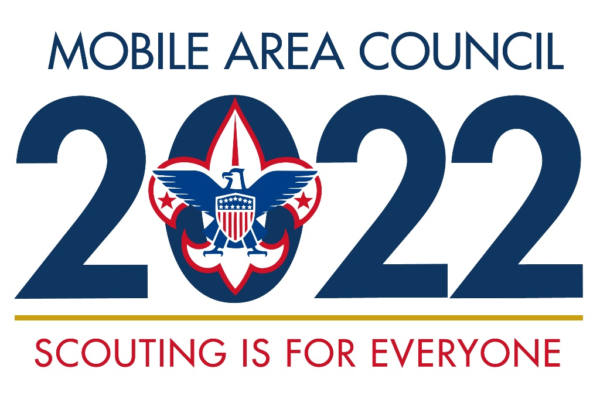

Scouts BSA Summer Camp
Camp Maubila

June 5th-11th, 2022
Leader Guide

Table of Contents

Contact Information 3
Reservation Guidelines 3
Camperships 4
Preparation and Guidelines for Camp 4
Recommended Troop Packing List 6
Recommended Individual Packing List 6
Check-In Procedures 8
Daily Schedule 9
Rawhide (First-Year Camper) Program 9
Program Booklets 10
Projected Merit Badge Schedule 10
Projected Merit Badge Schedule Condensed to One Page 17
Scout Early Release Form 18
Troop Registration Deposit Form 19
Camp Fee Payment Form 20

Contact Information

Camp Director: Peet Wert
- john.wert@scouting.org
- (251) 476-4600 (office)
- (251) 751-4053 (cell)
Program Manager: Nick Dagostino
- nickdagostino85@gmail.com
- (205) 886-1234 (cell)

Reservation Guidelines

Campsite Reservation

To assure your unit’s campsite preference, it is imperative to get all your camp registration fees in early. No troop will be permitted to ‘walk in’ without registering at least one week prior to the start of camp. A reservation deposit is necessary to ensure availability and site choice.

A reservation deposit of $100 is due when a troop turns in its registration deposit form (attached near the end of this leader’s guide). This reservation deposit is credited towards the troop’s summer camp bill (it is not a separate fee). Reservation deposits are non-refundable.

Youth Camp Fee Schedule

Camp fees are determined based upon the date that a scout is registered for summer camp.

 | Due Date | Price Per Scout
Early Bird Price | April 15, 2022 | $225
Base Registration | May 13, 2022 | $265
Late Registration | June 1, 2022 | $300

Youth Discount for Winter Camp Participation

Youth Winter Camp attendees will receive a $20 non-transferable discount.

Leader Fees

The cost per adult leaders is $55. Leaders may mix-and-match their schedules / share the leader fee (e.g., combined, one leader attending Sunday through Wednesday and another adult attending Thursday through Saturday only need to pay one leader fee).

Additional Fees

Scouts taking handicraft merit badges need to purchase the kits for those merit badges. These can be purchased at the trading post for about $10-$15 per kit.

Fees are NON-REFUNDABLE, but are Transferrable Under Certain Conditions

Summer Camp fees are non-refundable.

Summer Camp fees that have been paid may be transferred to another Scout who has not previously registered. A troop seeking to transfer summer camp fees must inform the Council Service Center of the change in who will be attending.

The transfer of Summer Camp fees is allowed only for paying for Summer Camp, not other activities.

The Winter Camp discount is non-transferrable.

Camperships

The purpose of council camperships is to aid Scouts who otherwise could not afford the fees to attend long-term camping opportunities sponsored by the Council. The amount of available funds vary from season to season, depending on our generous sponsors.

All campership applications must be received at the Council Service Center or by the Summer Camp Director no later than April 15, 2022, for review by the Campership Committee.

To receive a campership application, email Bernadette Toler at Bernadette.Toler@scouting.org, go to our bsamac.org website Events page, or get a form at the Council Service Center.

Policies

- Campership funds will be awarded on a first come, first served basis until funds are exhausted.

- Usually less than half (but no more than half) of the camp fee will be granted from campership funds, unless clearly justified.

- Applications and letters of request must clearly indicate any circumstances that prevent the Scout from earning part of the fee by his or her own efforts.

- The campership is based on the early bird fee. Once a campership is approved, the individual must submit his or her portion of the fees by the appropriate date.

- All recipients will write a thank you card to donors during their time at camp.

Preparation and Guidelines for Camp

Scouts Bring Their Own Tents

Scouts are responsible for providing and setting-up their own tents. If a scout needs a tent to attend summer camp, please make this need known to a leader listed in “Contact Information,” near the beginning of this guide, and a tent will be provided.

Adult Leadership

Each troop registering provides its own leadership. Troops must have two-deep leadership AT ALL TIMES, NO EXCEPTIONS. The Unit Leader must be a BSA registered adult, 21 years of age or older, with a current Youth Protection Training on file. It is the responsibility of the Unit Committee to be knowledgeable of attendees and provide trained and able leadership for this event.

Troops with a large number of scouts attending should secure enough assistant scoutmasters to meet the recommended ratios:
- 5 to 10 Scouts - 2 Leaders
- 11 to 20 Scouts - 3 Leaders
- 21 to 30 Scouts - 4 Leaders

Physical Exams, Health Forms, and The Health Lodge

Every scout, leader, and attending adult must have a valid BSA Health Examination Form Parts A, B, and C filled out completely and updated each year. Any person without this form WILL BE SENT HOME. These free forms may be found online or at the Council Service Center.

The Health Lodge will be staffed by a skilled medic under the direction of the Camp Physician and Camp Director. Arrangements have been made with local hospitals to handle any emergency treatments.

Insurance

All Scouts and Scouters are required to have current insurance coverage. A copy of their insurance card must be attached to their health form. In addition, ALL registered Scouts and Scouters of the Mobile Area Council, BSA are covered by a Health and Accident Insurance Policy for the period of their stay at camp. It is therefore necessary for every Scout to be checked in and out at the Camp Office. Claims can be filed for all illnesses and accidents requiring medical care not provided in the Camp Health Lodge. Every illness or accident must be reported to the Health Officer immediately to receive insurance coverage. Medical expenses incurred after leaving camp, resulting from an accident or illness taking place at camp, must be submitted immediately to the Council for clearance with the insurance company.

Provisional Campers

Maubila Scout Reservation will offer provisional camping as an option for scouts not attending camp with their troop or for out-of-council campers. Please note on the registration form when registering provisional campers. You may do so by writing “provisional” by the Scout’s name.

Transportation

Suitable transportation for scouts is a very important matter. According to the Guide to Safe Scouting, scouts are not allowed to drive a vehicle to or from Summer Camp. They are not covered under Boy Scout Accident & Sickness Insurance while driving.

Arrival Time

Troops should arrive at camp, on Sunday, no earlier than 1:00pm and no later than 3:00pm. Arriving to camp early causes unnecessary waiting and arriving too late causes a troop to miss the required check-in and orientation.

Departure Time

Troops should be prepared to leave by 10:00 a.m. on Saturday. A staff member will be assigned to assist you in checking out. Early troop departures must be coordinated the day before with the Camp Director and Program Manager.

Leaving and Returning to Camp

Camp Maubila is a Scouts BSA Camp and the Mobile Area Council, BSA is responsible for all personnel. We ask that you instruct your scouts that no one is to leave the camp without first getting permission from their unit leader, and second, the permission of the Camp Director. Anyone who leaves camp for any reason must sign out at the Camp Office before leaving and sign back in upon return. This applies to unit leaders as well.

Dining Hall

Wholesome food is prepared and served by a professional staff of food service personnel. Scouts sit by troop. Please allow seating for staff members to eat with your troops.

Trading Post

The camp Trading Post is open each day. A schedule will be posted for operating hours. Ice cream, candy, snacks, soft drinks, BSA catalog items, camp souvenirs, handicraft kits, and sundries are available for purchase. The Trading Post accepts cash and credit cards. Parents / guardians are responsible for any non-sufficient charges their child acquires while at camp.

History shows that a scout will spend around $75.00 during their stay at camp.

Vehicles in Camp

Vehicles may be driven only as far as the parking lot, with the exception of the Sunday check-in. Only camp vehicles and delivery trucks will be allowed on camp roads, per National Camp Standards. The roads are narrow and dangerous with Scouts walking around camp. If you need an item transported, check with the Camp Office.

Scouts are not permitted to be transported in the back of vehicles or trailers at any time.

General Cleanliness

Good Scouting is clean…clean camp, clean speech, and clean personage. We ask you to pay special attention to the cleanliness of your scouts and your campsite.

Visitors

All visitors are required to check in at the Camp Office.

Visitors are welcome at camp and are encouraged to attend our Family Night Campfire on Friday at 8:15pm. Visitors are invited to dine with their scouts in the Dining Hall on Friday night at 6:15pm. Unit leaders will need to submit a total number of campers and visitors who will be eating in the Dining Hall to the Camp Director by lunch on Thursday to ensure enough food is prepared. Visitors may pay for and pick-up their meal tickets for our Friday dinner at the Camp Office.

Visitors at camp may eat meals at the dining hall, for the following prices, provided there is enough food to accommodate visitors in addition to youth and adults who are staying at camp. Visitors paying for meals should be coordinated with the Camp Director or Program Manager.
- Breakfast: $5
- Lunch: $6
- Dinner: $7

Unauthorized Persons at Camp

- If any leader or camp staff member sees a person in camp without appropriate identification, please ask them in a courteous manner the nature of their business.

- Ask them to please report with you to the camp office for approval to be on camp property. They will be required to check-in.

- The above procedures are to be covered during staff week training and the first scoutmaster meeting.

Recommended Troop Packing List

Troops should pack to prepare their campsite as they see fit. When packing, one concern troops are encouraged to be especially aware of is hydration.

Recommended Individual Packing List

- Basic clothing
- Appropriate footwear for participating at an outdoor camp
- Scout uniform
- Rain gear
- Tent -or- Hammock (must provide own sleeping arrangements)
- Flashlight and batteries
- Swimsuit and towel
- Sleeping gear (sleeping bag, pillow, etc…)
- Water bottle
- Dental hygiene products
- Showering items (towels, soap, etc…)
- Bible and/or other worship material
- Spending money

Check-In Procedures

**You must have all current, completed medical forms: A, B, and C with medications in hand for each camper at check-in. Campers without Part C will not be permitted to stay at camp, per National BSA Safety and Health Guidelines.

- A troop guide will meet you in the parking lot when you arrive. They will meet with the unit while the Scoutmaster goes to the Camp Office to check-in. The Scoutmaster should have a completed unit roster and any outstanding fees prepared. You must have all completed medical forms A, B, and C with medications in hand for each camper at this time. Waterfront / swimming buddy tags will be issued at this time, based on the health forms submitted.

- Once the Scoutmaster has checked-in the troop, the troop returns to the parking lot and moves equipment to its campsite. Adults are permitted to use their vehicles to transport gear and then must immediately return all vehicles to the parking lot. This is NOT the time to set up camp.

- Have all persons who think they may participate in water-based activities, scouts and adults, get into swimsuits with shoes and towels to be prepared to complete a swim check.

- Once your troop has brought its equipment to its campsite and prepared for the swim check, its troop guide will lead the troop to the Dining Hall for an explanation of Dining Hall responsibilities and expectations.

- Next, your troop will go to the swimming pool or waterfront, as assigned, where each scout and adult who plans on participating in water activities must take a swim classification test. All individuals will be classified as a non-swimmer, beginner, or swimmer.

- After completing the swim check, your troop will return to its campsite to work on setting it up for the week.

- All troops will assemble at the flagpole in BSA Field Uniform by 6:10pm to prepare for supper.

Daily Schedule

Below is the general summer camp schedule for Monday through Thursday.

PLEASE NOTE: Blocks #1 and #3 are about twice as long as Blocks #2 and #4. For most merit badges, scouts will be able to sign-up for two merit badges during each of these longer blocks. They will work on the first merit badge on Monday and Tuesday and the second merit badge on Wednesday and Thursday.
- One important purpose of this change is to maximize how productive we are at camp by minimizing the time spent traveling between different instructional opportunities.

8:00am | Waiter’s Call
8:10am | Flag Ceremony
8:15am to 8:50am | Breakfast
9:00am to 10:50am | Block #1 (A + B)
11:00am to 11:50am | Block #2
12:00pm | Waiter’s Call
12:10pm to 12:45pm | Lunch
12:50pm to 2:20pm | Post-Lunch Activity / Free Time
2:30pm to 4:20pm | Block #3 (A + B)
4:30pm to 5:20pm | Block #4
6:00pm | Waiter’s Call
6:10pm | Flag Ceremony
6:15pm to 7:00pm | Dinner
7:00pm | Evening Activities Start

Rawhide (First-Year Camper) Program

We recommend that first-year campers who still need to complete a majority of the Tenderfoot, Second Class, and First Class ranks participate in the Rawhide program. That said, there are several considerations relevant to determining which summer camp program is best for a particular scout. Participation in the Rawhide program is left to the discretion of the Scoutmaster.

Prioritized requirements (the focus will be quality over quantity):

Tenderfoot: 1b, 1c, 2a, 2b, 3a, 3b, 3c, 3d, 4a, 4c, 4d, 5a, 5b, 5c, 7a, and 8
Second Class: 2a, 2b, 2c, 2d, 2e, 2f, 2g, 3a, 3d, 5a, 5b, 5c, 5d, 6a, 6b, 6c, 6d, 6e, 8a, and 8b
First Class: 2d, 3a, 3b, 3c, 3d, 4a, 4b, 5b, 5c, 5d, 6a, 6b, 6c, 6d, 6e, 7a, 7b, 7c, 7f, and 9a

First Aid

In addition to Tenderfoot through First Class requirements, scouts in the Rawhide Program will have the opportunity to complete the first aid merit badge.

Swimming

Scouts in the Rawhide Program will either work towards the swimming merit badge or receive swimming instruction, depending upon their swimming ability.

Program Booklets

During the check-in process, all youth and adults will be provided with a program booklet. This booklet will serve as a guide to the week’s activities that scouts can carry with them.

Projected Merit Badge Schedule

How many merit badges are offered per block will depend upon how many scouts register to work on merit badges. Merit badge (and Rawhide) sign-up materials will be distributed starting Monday, April 4, 2022.

Blocks 1A and 1B are considered two separate blocks, as are 3A and 3B. For Blocks 1 and 3, the “A” session is on Monday and Tuesday and the “B” session is on Wednesday and Thursday. Blocks 1 and 3 are about twice as long as the other blocks to allow for instruction to be completed in two days, instead of four. If this is confusing, please refer to the “Merit Badge Schedule Condensed to One Page” section (below). Block 4 is primarily intended for free time, but a couple simple merit badges will be offered.

Block 1A

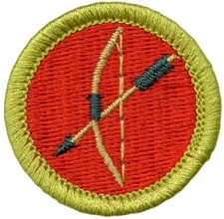 | - Archery (MUST TAKE BLOCKS 1A and 1B)  Scouts who participate fully are expected to earn this merit badge while at camp.  Scouts must meet a minimum score requirement for shooting accuracy.
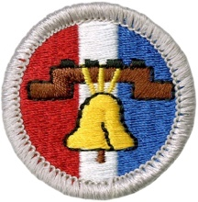 | - Citizenship in the Nation  Scouts will receive a partial (requirement 3 and possibly requirement 2 will not be completed at camp).
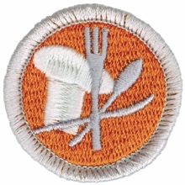 | - Cooking  Cooking merit badge cannot be completed at summer camp. Scouts will receive a partial. The focuses for cooking merit badge will be (1) understanding the role cooking has in the Scouting program, and (2) learning interesting methods for cooking outdoors.
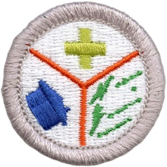 | - Emergency Preparedness  Scouts who participate fully are expected to earn this badge while at camp.  FIRST AID MERIT BADGE IS A PREREQUISITE.
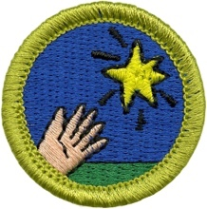 | - Entrepreneurship  Scouts who participate fully are expected to earn this badge while at camp.
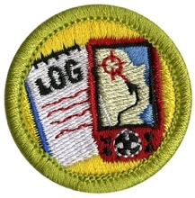 | - Geocaching  Scouts will likely earn a partial (requirements 8 and 9 will probably not be completed at camp), but every effort will be made to leave them well prepared to complete this merit badge at home.
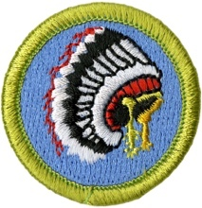 | - Indian Lore  Scouts who participate fully are expected to earn this badge while at camp.
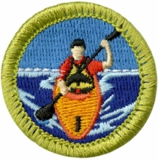 | - Kayaking (MUST TAKE BLOCKS 1A and 1B)  Scouts who participate fully are expected to earn this badge while at camp.
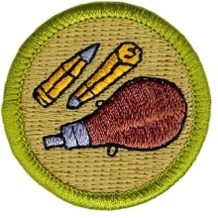 | - Rifle Shooting (MUST TAKE BLOCKS 1A and 1B)  Scouts who participate fully are expected to earn this merit badge while at camp.  Scouts must meet a minimum score requirement for shooting accuracy.
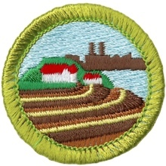 | - Soil and Water Conservation  Scouts who participate fully are expected to earn this badge while at camp.
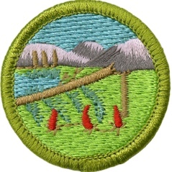 | - Wilderness Survival  Scouts who participate fully are expected to earn this badge while at camp.  Scouts must complete an overnight stay in an improvised natural shelter.

Block 1B

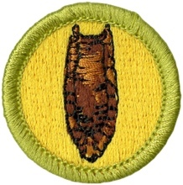 | - Archaeology  Scouts who participate fully will likely earn this merit badge, with requirement 7 being the possible reason for a partial, which is easy to complete at home.
  - Archery (MUST TAKE BLOCKS 1A and 1B)
Scouts who participate fully are expected to earn this merit badge while at camp.
Scouts must meet a minimum score requirement for shooting accuracy.
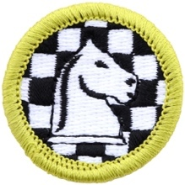 | - Chess  Scouts who participate fully are expected to earn this badge while at camp.
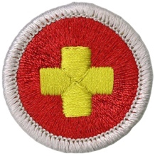 | - First Aid  Scouts who participate fully are expected to earn this badge while at camp.
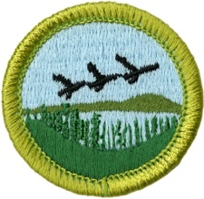 | - Fish and Wildlife Management  Scouts who participate fully are expected to earn this merit badge while at camp.
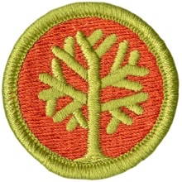 | - Genealogy  Scouts will receive a partial, but this merit badge is easy to complete at home.
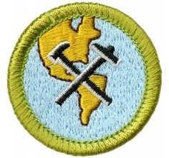 | - Geology  Scouts who participate fully are expected to earn this merit badge while at camp.
  - Kayaking (MUST TAKE BLOCKS 1A and 1B)
Scouts who participate fully are expected to earn this badge while at camp.

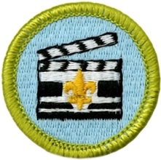 | - Moviemaking  Scouts who participate fully are expected to earn this badge while at camp.
  - Rifle Shooting (MUST TAKE BLOCKS 1A and 1B)
Scouts who participate fully are expected to earn this merit badge while at camp.
Scouts must meet a minimum score requirement for shooting accuracy.

  - Sustainability
Scouts will receive a partial, several aspects of this merit badge must be completed at home.

Block 2

  - Citizenship in Society
Scouts who participate fully are expected to earn this badge while at camp.
  - Citizenship in the Nation
Scouts will receive a partial (requirement 3 and possibly requirement 2 will not be completed at camp).
  - Citizenship in the World
Scouts who participate fully are expected to earn this merit badge while at camp.

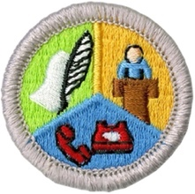 | - Communication  Scouts who participate fully are expected to earn this badge while at camp (requirement 5 will likely be addressed with a recorded meeting).
  - Emergency Preparedness
Scouts who participate fully are expected to earn this badge while at camp.
FIRST AID MERIT BADGE IS A PREREQUISITE.
  - Environmental Science
Scouts who participate fully are expected to earn this badge while at camp.
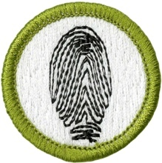 | - Fingerprinting  Scouts who participate fully are expected to earn this badge while at camp.
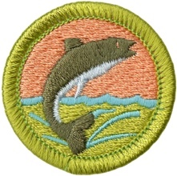 | - Fishing  Scouts who participate fully are expected to earn this badge while at camp.  The scout must catch a fish.
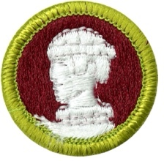 | - Sculpture  Scouts who participate fully are expected to earn this merit badge while at camp.
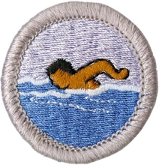 | - Swimming  Scouts who participate fully are expected to earn this merit badge while at camp.  The scout must meet performance requirements.

Block 3A

  - Citizenship in the World
Scouts who participate fully are expected to earn this badge while at camp.
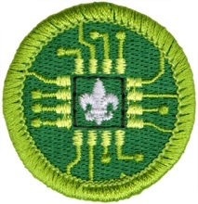 | - Digital Technology  Scouts who participate fully are expected to earn this merit badge while at camp.  Scouts must have an up-to-date Cyber Chip.
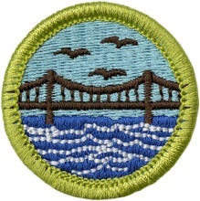 | - Engineering  Scouts who participate fully are expected to earn this merit badge while at camp.
  - Environmental Science
Scouts who participate fully are expected to earn this merit badge while at camp.

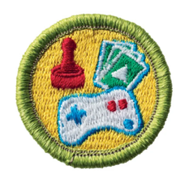 | - Game Design  Scouts who participate fully are expected to earn this merit badge while at camp.
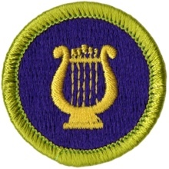 | - Music  Scouts who participate fully will probably earn this merit badge at camp, but they may have some really easy work to do at home for requirement 3.
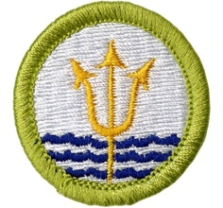 | - Oceanography  Scouts who participate fully are expected to earn this merit badge while at camp.
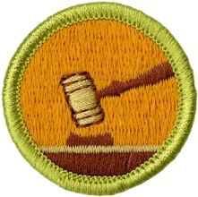 | - Public Speaking  Scouts who participate fully are expected to earn this merit badge while at camp.
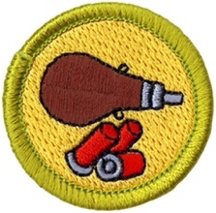 | - Shotgun Shooting (MUST TAKE BLOCKS 3A and 3B)  Scouts who participate fully are expected to earn this merit badge while at camp.  Scouts must meet a minimum score requirement for shooting accuracy.

Block 3B

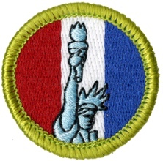 | - American Heritage  Scouts who participate fully are expected to earn this merit badge while at camp.
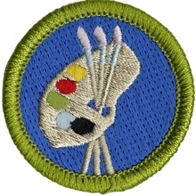 | - Art  Scouts who participate fully are expected to earn this merit badge while at camp (requirement 6 will likely be completed remotely).
  - Communications
Scouts who participate fully are expected to earn this badge while at camp (requirement 5 will likely be addressed with a recorded meeting).
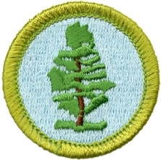 | - Forestry  Scouts who participate fully are expected to earn this merit badge while at camp.
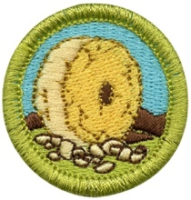 | - Inventing  Scouts who participate fully are expected to earn this merit badge while at camp (requirement 8 will likely be completed remotely).
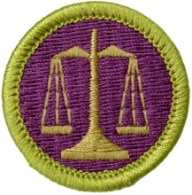 | - Law  Scouts who participate fully are expected to earn this merit badge while at camp.
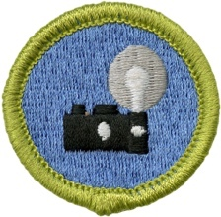 | - Photography  Scouts who participate fully are expected to earn this merit badge while at camp.  Scouts must have an up-to-date Cyber Chip.
  - Shotgun Shooting (MUST TAKE BLOCKS 3A and 3B)
Scouts who participate fully are expected to earn this merit badge while at camp.
Scouts must meet a minimum score requirement for shooting accuracy.

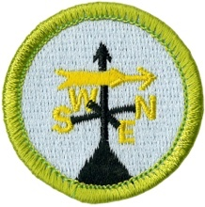 | - Weather  Scouts may or may not complete this merit badge, depending upon the ability to complete requirement 9 at camp. At the very least, every effort will be made to ensure that scouts are prepared to complete the merit badge at home.

Block 4

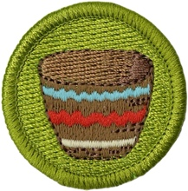 | - Basketry  Scouts who participate fully are expected to earn this merit badge while at camp.  Scouts must purchase a basketry kit for this merit badge.
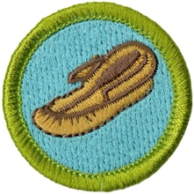 | - Leatherwork  Scouts who participate fully are expected to earn this merit badge while at camp.  Scouts must purchase a leatherworking kit for this merit badge.

Merit Badge Schedule Condensed to One Page

 | Monday + Tuesday | Wednesday + Thursday
Block #1A + 1B  9:00 to 10:50 | Citizenship in the Nation  Moviemaking | First Aid  Fish and Wildlife Management  Geology
Block #2  11:00 to 11:50 | Citizenship in Society  Open Range (Shooting Sports)  Weather
Block #3A + 3B  2:30 to 4:20  *Rawhide Swimming Instruction | Citizenship in the World  Engineering  Environmental Science  Swimming | Communications  Digital Technology  Forestry  Weather
Block #4  4:30 to 5:20 | Basketry  Leatherworking  Open Pool

Scout Early Release Form

Any parent or guardian desiring to pick up their Scout early from summer camp prior to their unit’s departure must have this release form filled out in advance by the parent’s or guardian.

Request is made that:__________________________________________________________________

Home Address:_______________________________________________________________________

City:______________________________________________State:_____________Zip:_____________

Unit #:____________________________________Telephone #:_______________________________

The Scout is to leave on: Date:______________________________ Time:_______________________

Person pickup up Scout:________________________________________________________________

Address:____________________________________________________________________________

City:______________________________________________State:____________Zip:______________

In signing this request for release, the BSA, the local BSA council, the troop leaders or their representatives shall not be held liable for any loss or injury to the Scout’s person or property.

Parent’s or guardian’s signature:_________________________________________________________

Address:____________________________________________________________________________

City:______________________________________________State:____________Zip:______________

Telephone: (H)______________________ (W)_____________________

Before leaving the camp, Scout must check out with their Unit Leader and the Camp Director.

Unit Leader:_______________________________Unit:__________________Date:_________________

Camp Director:___________________________________________________Date:_________________

Camp Maubila Summer Camp 2022

Troop Registration Deposit Form

Troop # __________ District ______________ Date Reservation Deposit ($100) Paid: __________

Ranked List of Preferred Campsites (May Be Shared with Another Troop):

- ________________________________

- ________________________________

- ________________________________

Troop Leader in Charge for Summer Camp

Name: ___________________________________ Phone: ______________________________

Email: ________________________________________________

Expected Troop Attendance

Estimated number of scouts attending: _____

Estimated number of adults attending: _____

Does your Troop anticipate having scouts participate in the Rawhide (first-year camper) Program: yes / no

- If so, approximately how many scouts do you expect to have participate? _____

**The estimated attendance numbers are not to lock troops into sending a certain number of youth or adult to camp. Rather, camp leadership appreciates troops providing an estimate to facilitate general planning.

Camp Maubila Summer Camp 2022

Camp Fee Payment Form

Troop # __________ District ______________ Date Form and Fees Submitted: __________

Youth Camp Fees

 | Due Date | Price Per Scout
Early Bird Price | April 15, 2022 | $225
On-Time Registration | May 13, 2022 | $265
Late Registration | June 1, 2022 | $300

Adult Leader Camp Fees

The cost per adult leaders is $55. Leaders may mix-and-match their schedules / share the leader fee (e.g., combined, one leader attending Sunday through Wednesday and another adult attending Thursday through Saturday only need to pay one leader fee).

Calculating Your Troop’s Camp Fees

Youth Fees: __________ x __________ = __________
(# of youth) (price per youth)

Leader Fees: __________ x ___$55____ = + __________
(# of adults)

Campership Awards - __________

Youth Winter Camp Discount: __________ x ____$20____ = - __________

Reservation Deposit: - ___$100___
- Date paid: _______________

Total Fees Due: __________

NOTE: A troop may submit multiple copies of this form to pay for groups of scouts at different times.

ATTACH A ROSTER OF THE SCOUTS AND ADULTS BEING PAID FOR TO THIS FORM

