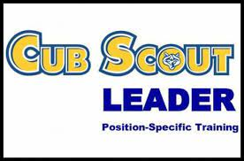

Who? Cubmaster, Asst. Cubmaster, Den Leader, and Asst. Den Leader, Committee Chairman & Committee Members

What? This course is intended to provide the following positions with the information and tools they need to conduct a successful program. Leaders who complete the training are considered trained for their position.

When? 7pm – 8:30 pm, September 30, 2022 and 7:30am -10:00 am on – October 1, 2022

Where? At the Cub Scout Battleship Overnighter *** Must have someone to watch your scout while you are attending the training***

Contact: Scout Service Center at (251) 476-4600, Doug Phillips at (251) 533-0603 and spillihpd71@gmail.com, or your District Training Chairman for additional information.

Cub Leader Position-Specific Training
www.cubleadertraining2022.eventbrite.com

Unit #____________
Name(s) _________________________________________________________________________
Email_____________________________________________ Phone #_____________________

_____________________________________________________________
Registration Fee ____________ @ $5.00 ea. = _________ Paid before 9/16/22, 12noon. **No day of registration will be permitted**

Method of Payment: Cash Check # ________ Visa / MasterCard
Credit Card #______________________________________________
Expiration_________ Signature_____________________________________

