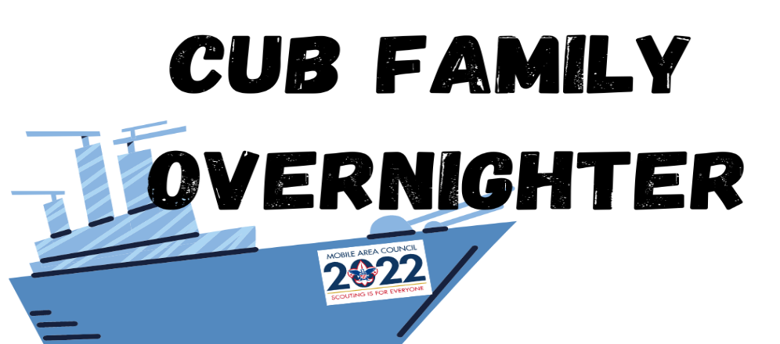

WHEN: September 30-October 1, 2022 (Check-in between 5-7 pm on Friday. Checkout is at 11 am on Saturday.)
WHERE: USS ALABAMA Battleship Memorial Park, Battleship Parkway, Mobile, Alabama

WHO: All registered Cub Scouts and their families. Each scout must be accompanied by an Adult
Partner at least 21 years of age at all times. This is a parent/child activity.

COST: $15.00 per person until 9/16/22, 5:00 pm. 9/17 until 9/28 the registration fee is $25.00 per person. (Siblings under 5 attend free)

The Trading Post (Concession Stand) will be selling hamburgers, hot dogs, chips and drinks Friday Night Only.
Registration fee pays for a patch for scouts, activities, and continental breakfast for all paid attendees.

WHAT TO BRING: Tent, ground cloth, sleeping bag or blankets, pillow, flashlight, rain gear, toiletries, insect
repellant, money for Trading Post, or your own food for Friday evening.

** NOBODY IS CAMPING ON THE BATTLESHIP **
NO Ground Fires & NO flames of any kind on the premises or in tents – Flashlights only!
NO Camping allowed under any of the aircraft.
You may not leave your Cub Scout unattended. (See Cub Scout Family Overnighter Campout Rules on reverse side).
Register Online: https://cubfamilycampout2022.eventbrite.com

USS Alabama Battleship Cub Scout Overnighter September 30-October 1, 2022

Must register by Wednesday, September 28, 5pm
Fill out this form and deliver/mail /email to:
Mary.Phillips@scouting.org or Brandon.Anderson@scouting.org

Mobile Area Council, 2587 Government Blvd, Mobile, AL 36606

Phone: 251-476-4600
Pack #_______
Phone___________________________________ Email____________________________________ Names_____________________________________________________________________ __________________________________________________________________________

____ Scouts @ $15, by September 16 ____ Scouts @ $25, between September 17-28
____ Adults @ $15, by September 16 ____ Adults @ $25, between September 17-28
____ Siblings @ $15, September 16 ____ Siblings @ $25, between September 17-28
____ Siblings Under 5 free ____ Siblings Under 5 free
$________ Total Paid by September 16 $ ________ Total paid by September 28

Check#________ Credit Card Sig.___________________ Receipt#___________
Credit Card Number_______________________________________ Exp._______
No Tents Provided;
No RV or Pop-Up Campers Allowed

MOBILE AREA COUNCIL, BOY SCOUTS OF AMERICA
Cub Scout Family Overnighter Campout Rules

- This is a family event. You should know where your family members are at all times. (They are your responsibility!) Please keep up with each other.

- Absolutely NO open flames of any kind on the grass or in canopy/tents. This includes lanterns, candles, any open flames, camp stove, small grill, or any apparatus that is not battery operated.

- Alcoholic beverages are prohibited, as well as any form of drugs that you are not under a doctor’s prescription to take. Firearms of any kind are also prohibited.

- Since this is a family activity, camping is with family members, not by units. Units can camp near each other, if desired.

- A Trading Post will be opened to sell pizza and drinks Friday evening.

- Campfire starts at 8 p.m.

- First Aid is available in the Trading Post area.

- NO OPEN FIRES!

- Remember A Scout Is Clean. Please pick up all litter that you bring and take it with you. A bag is provided with your breakfast for your trash.

- Scout patches for the campout may be picked up upon check-in.

- Please refrain from smoking or vaping while at this Cub Scout event.

- No camping is allowed under the aircraft. The Memorial Grounds open field fits all camping families.

- Please do not leave your Cub Scout unattended or allow them to climb on displays while at the park.

- LOST & FOUND (Children, Adults and other items of value will be maintained at the Trading Post.)

- No pets are allowed at BSA events.

