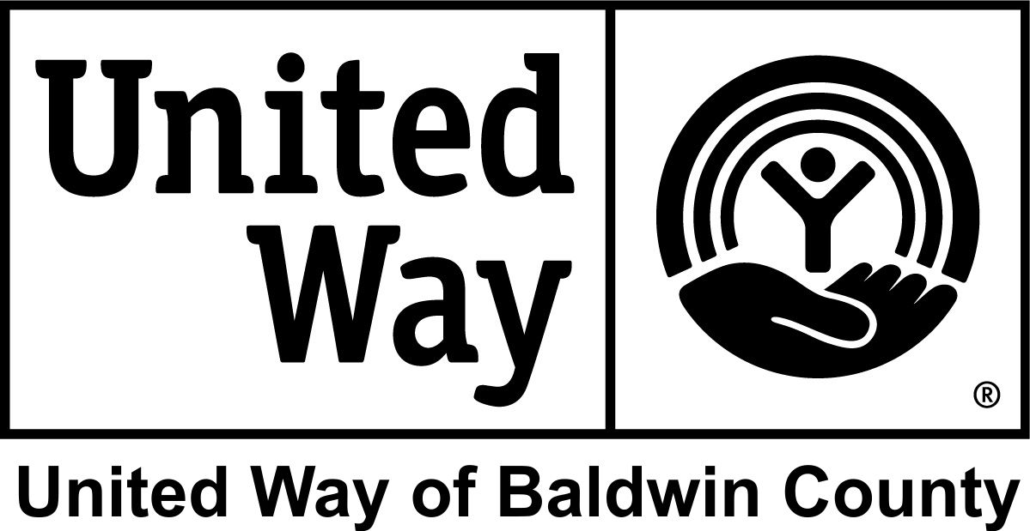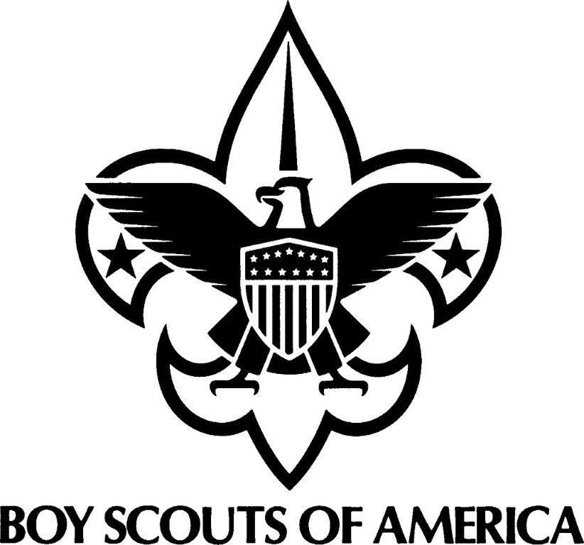

United Way of Baldwin County and Baldwin County
Reimbursement Form
Boy Scouts of America, Baldwin County Children

Boy Scout Scholarship Information

Date__________________

Child’s Name__________________________________________________________

DOB ______________ Age ______________ M or F ______ Race_______________

Parent or Guardian ______________________________________________________

Address_______________________________________________________________

City _____________________________ Zip __________ Phone__________________

Troop Name____________________________________________________________

Troop Location _________________________________________________________

Reason for Scholarship __________________________________________________

I certify that the child named above will be participating in a Baldwin County Boy Scout Troop and has been awarded a scholarship in the amount below.

$_________________ __________________________________
Scholarship Amount Boy Scout Troop Representative

________________________________
Boy Scout Executive Director

Please email completed form to Bernadette.Toler@scouting.org
or Mary.Phillips@scouting.org or mail to
Attn: Scholarship/Campership
Mobile Area Council, BSA
2587 Government Blvd.
Mobile, AL 36606

For United Way use only:

Approved by ________________________________________
Date Paid __________ Amount Paid ________ Check #_______ By______

