The Mobile Area Council Boy Scouts of America

***2021 Executive Committee of the Board of Directors***

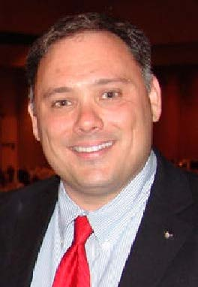

President

**James Alexander lll**

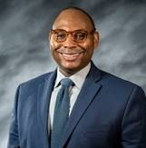

Scout Executive/CEO

**William Bryant, Jr.**

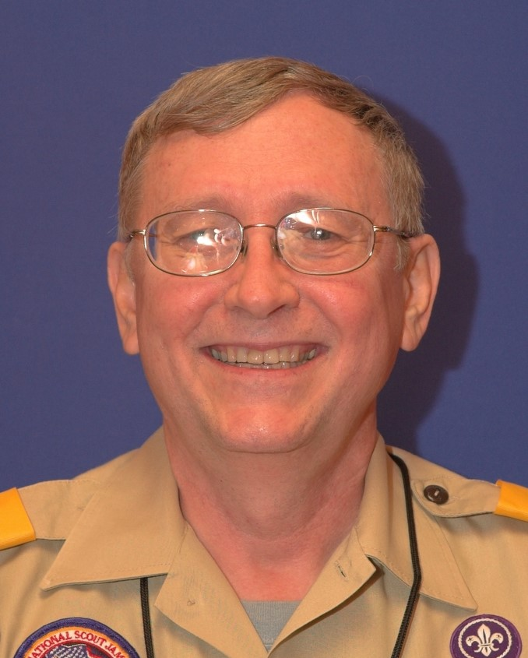

Commissioner

**Wayne Sirmon**



Legal Counsel

**Lee Webb**

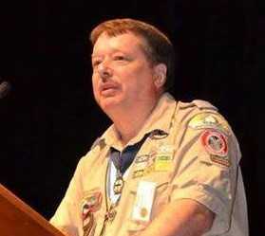

**VP Programs**

**Paul Roberts**

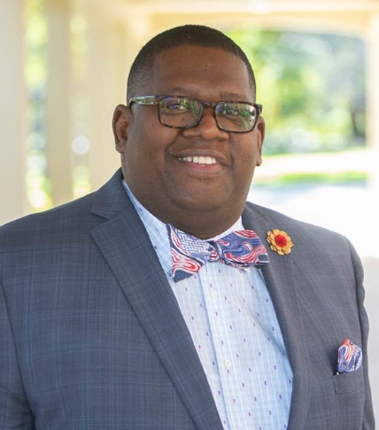

**VP Multicultural Affairs**

**Dr. Paul Frazier**

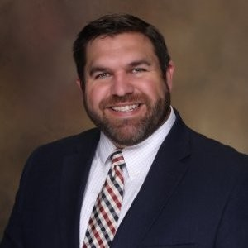

**VP Endowment**

**Chad Jones**

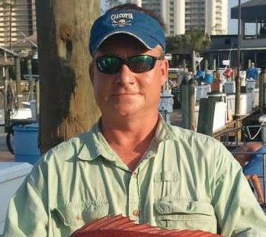

VP Camp Programs

**Shannon Miller**



**VP Development**

**Dr. George Inge**

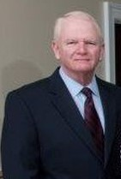

**VP Finance**

**F. Michael Johnson**



**Treasurer**

**Mike Box**

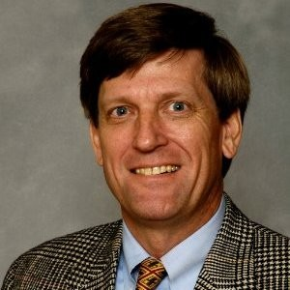

VP Risk Management

**Bill Pipkin**

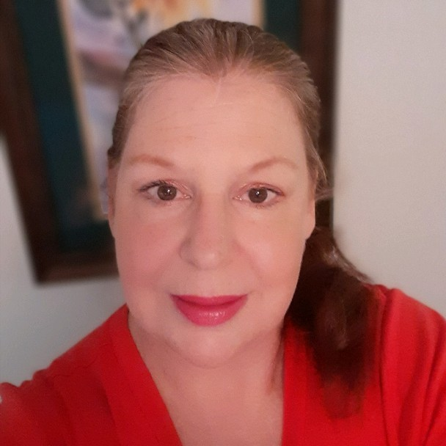

**VP Membership**

**Edith Gray**

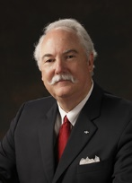

**VP Strategic Recruitment**

**David Roberts, Jr.** 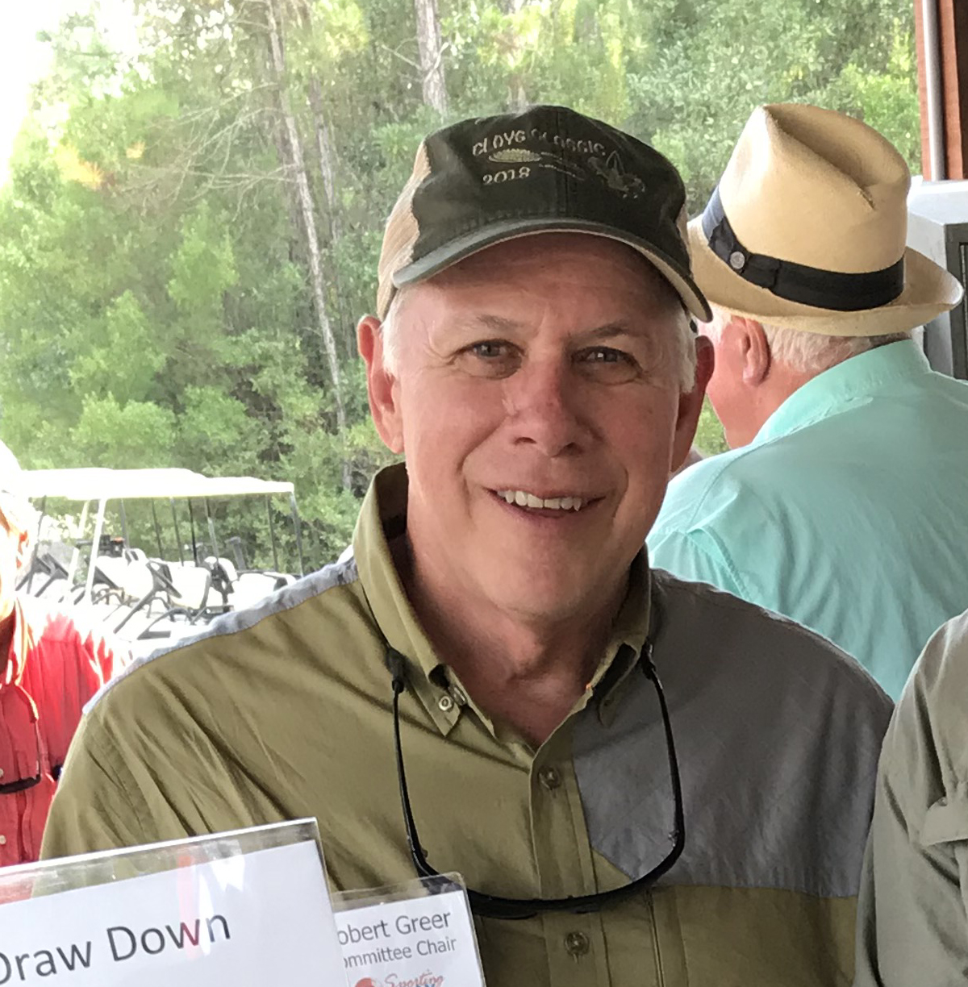

**VP Strategic Recruitment**

**Robert Greer**

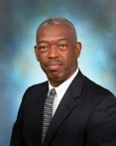

VP Exploring

**Stan Chavis**

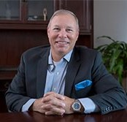

**National Council Rep.**

**Ken Styron 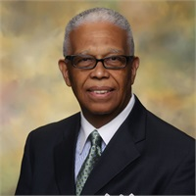National Council Rep.**

**Charles Holloway**

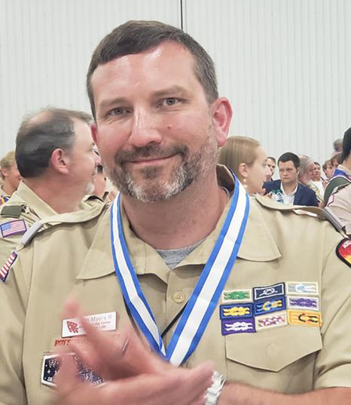

**VP Physical Resources**

**John Myers**



**VP High Adventure**

**Charlie Simpson**

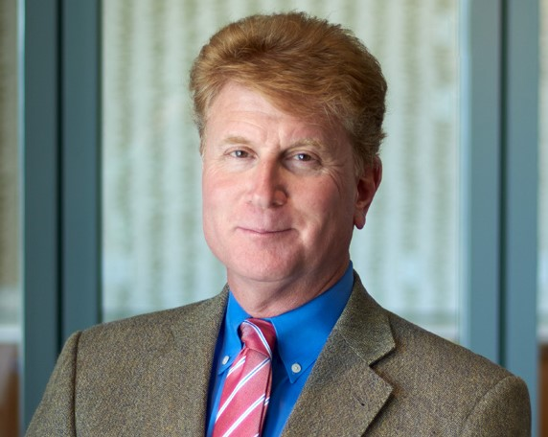

VP Special Events

**Jay Ross**